Project Synopsis on

# Virtual Assistant

Submitted as a part of the course curriculum for

# Bachelor of Technology

in

# Computer Science



**Submitted by**

Suraj Gupta (2000290120168) Sushant Kumar Pandey (2000290120172)

Srijan Shahi (2000290120165)

**Under the Supervision of** Ms. Anshula Gupta Assistant Professor

Department of Computer Science

# KIET Group of Institutions, Ghaziabad Department of Computer Science

**Dr. A. P. J. Abdul Kalam Technical University 2022-2023**

# TABLE OF CONTENTS

DECLARATION CERTIFICATE ACKNOWLEDGEMENT ABSTRACT

LIST OF FIGURES

LIST OF ABBREVIATIONS

CHAPTER 1 INTRODUCTION

* 1. Introduction
  2. Problem Statement
  3. Objective
  4. Scope

CHAPTER 2 LITERATURE REVIEW CHAPTER 3 PROPOSED METHODOLOGY CHAPTER 4 TECHNOLOGY USED CHAPTER 5 DIAGRAMS

CHAPTER 6 CONCLUSION REFERENCES

# DECLARATION

We hereby declare that this submission is our work and that, to the best of our knowledge and belief, it contains no material previously published or written by another person nor material which to a substantial extent has been accepted for the award of any other degree or diploma of the university or other institute of higher learning, except where due acknowledgment has been made in the text.

Signature of Students:

Name: Suraj Gupta (2000290120168)

Sushant Kumar Pandey (2000290120172) Srijan Shahi (2000290120165)

Date:

# CERTIFICATE

This is to certify that the Project Report entitled “**Virtual Assistant**” which is submitted by Suraj Gupta, Sushant Kumar Pandey, and Srijan Shahi in partial fulfillment of the requirement for the award of degree B. Tech. in the Department of **Computer Science** of Dr. A.P.J. Abdul Kalam Technical University, Lucknow is a record of the candidates own work carried out by them under my supervision. The matter embodied in this report is original and has not been submitted for the award of any other degree.

**Date: Supervisor Signature**

Ms. Anshula Gupta Assistant Professor

Department of Computer Science

# ACKNOWLEDGEMENT

It gives us a great sense of pleasure to present the synopsis of the B. Tech Mini Project undertaken during B.Tech. Third Year. We owe a special debt of gratitude to Ms. Anshula Gupta, Assistant Professor, Department of Computer Science, KIET Group of Institutions, Delhi- NCR, Ghaziabad, for his/her constant support and guidance throughout the course of our work. Her sincerity, thoroughness, and perseverance have been a constant source of inspiration for us. It is only her cognizant efforts that our endeavors have seen the light of day.

We also take the opportunity to acknowledge the contribution of Dr. Ajay Kumar Shrivastava, Head of the Department of Computer Science, KIET Group of Institutions, Delhi- NCR, Ghaziabad, for his full support and assistance during the development of the project. We also do not like to miss the opportunity to acknowledge the contribution of all the faculty members of the department for their kind assistance and cooperation during the development of our project.

Last but not the least, we acknowledge our friends for their contribution to the completion of the project.

Signature:

Date:

Name: Suraj Gupta (2000290120168)

Sushant Kumar Pandey (2000290120165) Srijan Shahi (2000290120165)

# ABSTRACT

Voice assistant is a majorly growing technology in today’s world which is commonly being used in many smartphones and laptops which have an approach for long-term usage or interaction of the person with the assistant which makes it more interactive. With the advancement of personal voice assistant, Python become a more emerging language so it becomes easy to write a script for Voice Assistant. This assistant is featured according to the user’s requirement which is starting from the basic commands to the complex commands. As the first step of the assistant is Speech recognition, which means converting the speech into text format, this conversion process is done by speech recognition API. This is commonly used in voice assistants like Alexa, Siri, Google Assistant, Cortana, etc. It can perform starting with basic commands (Send emails without typing any word, search without opening the browser, playing music, etc.) to moderate commands. In the present scenario, With the advancement of technology, it can perform any task with effectiveness, decreasing human efforts and saving more time.

# List of Figures

Fig 1.1 Workflow of Virtual Assistant

Fig 1.2 Block diagram of Virtual Assistant

# CHAPTER 1: INTRODUCTION

As personal voice assistant has become the main part of our day-to-day life. It is because of the advancement of technology and of all the features which an assistant provides. When Artificial Intelligence interacts with machines, then machines behave like humans. In this project, the user is just expected to give voice commands, and the rest work is done by our voice assistants which can automate the complete process and completes our task. As Virtual Assistants perform tasks as a human can. It can send emails, play music, and talk to you accordingly. In this project, we’ll use many of the APIs with different functionality like speech recognition API which will convert speech into text, Message Bird Voice Chat API which will make and receive calls,

Viber voice chat API can shift between conversations, block/unblock conversations, Turn On/Off notifications, and much more. To build this functionality, we will use different libraries and modules like Tkinter, Web browser, Ecapture, Pyjokes, Datetime, Twilio, Requests, pyPDF2, pyautogui, pyQt, and BeautifulSoup and at the end, we will create a live GUI for interacting with the JARVIS as it gives interesting look while having the conversation. So, utilizing of these features of personal voice assistants will save a lot of time and effort.

# PROBLEM STATEMENT

1. Understanding user voice commands.
2. Can't read, or send SMS/Emails.
3. Security Issues
4. Not able to read Notifications
5. No desktop app is available
6. Eavesdropping Aspect (Off automatically when there are no commands from the user end)
7. Misinterpretation because of accents.

# OBJECTIVE

As the already existing Virtual Assistants have some limitations like it can’t understand user voice commands, can’t read messages, and misinterpretation because of accents. To overcome these limitations, we will work on these functions to add on with the assistants which will save time, reduce human efforts and provide more clarity and productivity.

# SCOPE

With the addition of functionalities like reading, texting, playing, and listening, the assistant is able to:

* 1. Read the text messages, and notification content.
  2. Can give you remainders.
  3. Understand user voice commands.
  4. Can send emails/text messages.
  5. Saves time.
  6. Reduce human efforts.

# CHAPTER 2: LITERATURE REVIEW

Voice assistant is a major growing feature in the real world which is commonly being used in many smartphones and laptops which have an approach for long-term usage or interaction of the person with the assistant which makes it successful, user friendly, and more interactive. This AI Assistant system using Google Assistant, the service of open API, and the conditional auto-run system IFTTTF (If This, Then That) was designed. AI- based Voice Assistants are part of the operation that is based on the concept of FRTR (First Recognize Then Respond). This AI-based Assistant is the combination of three stages: Firstly, it takes input from the user then the assistant recognize the input based on three aspects: Cognitive Aspect (User’s thoughts, knowledge, concentration, area of interest (Music Streaming), Affective Aspect (a feeling of positive or negative inspirations OR state of emotional activity), Behavioral Aspect (User’s behavioral manifestations towards an object of interest, trust and risk factor are also considered). Now, our input is recognized and categorized accordingly. Then, the Assistant converts that input into text (Input to text), then, through the GTTS (Google Text to Speech) engine, converted into an audio file in English Language (Text To Speech), and This audio is played by using the play sound package of python Programming Language (Speech to action). Using this concept, many models are developed, Goal Net is one of the models proposed, which represents its goals and how it achieves those goals in a dynamic environment. In a dynamic environment, Goals are of two types, First is, Atomic Goals which are unable to decompose into subgoals, and Second Composite Goals which can be further breakdown into Atomic or composite goals. Goal Net also provides the feature of a Goal and action selection mechanism for deciding what goals to pursue and what tasks to execute based on situational criteria. Simple Goal Net consists of a root composite goal, two atomic goals, and an action. The second Hybrid Model named as k-12 E-Learning Assistant chatbot works as an assistant for the predefined queries in a website or any application which has some predefined queries and solutions for that query. These types of commercial chatbots typically use two types of models to be responsive: A retrieval-based model and a generative-based model. The third Model is Google Glass-based real-time scene analysis for visually impaired persons. This model is proposed for the BVIPs (Blind and Visually Impaired People) who face difficulties with tasks that involve scene recognition. In this model, many scenes are captured from surroundings which are to be analyzed by the custom API provided by Microsoft Azure. Vision API analyzes the captured image and converted that to speech, which gives output in the form of voice and this voice is heard by BVIP users wearing google glass. To improve efficiency, A dataset is created using the different scenes in different surroundings. This model efficiency improved by 21% and overall response time was less than 1 second. With these advancements in technology, privacy and Security become major issues. A comprised VA may be a stepping stone for attackers to hack into users’ phones. The attackers use voice commands to activate VA and

launch several tasks including private information, and sending irrelevant messages. VASPY is a Novel attack approach that includes the attacking environment sensing module to choose the optimal attacking time and found that VASPY can launch attacks without knowing the users.

# CHAPTER 3: PROPOSED METHODOLOGY

The IDE used in this project is PyCharm. All the python files were created in PyCharm and all the necessary packages were easily installable in this IDE. For this project following modules and libraries were used i.e., pyttsx3, Speech-Recognition, Datetime, Wikipedia, Smtplib, pywhatkit, pyjokes, pyPDF2, pyautogui, pyQt, etc. I have created a live GUI for interacting with the JARVIS as it gives a design and interesting look while having the conversation. With the advancement, JARVIS can perform any task with the same effectiveness and can say more effectively than us. By making this project. Functionalities of this project include, It can send emails, It can read PDFs, can send text on WhatsApp, can open the command prompt, your favorite IDE, notepad, etc., can play music, It can do Wikipedia search for you can open websites like Google, YouTube, etc., in a web browser, It can give weather forecast, It can give desktop reminders of your choice. It can have some basic conversation.

# CHAPTER 4: TECHNOLOGY USED

**pyttsx3**: It is a python library that converts text to speech.

**Speech Recognition**: It is a python module that converts speech to text.

**pywhatkit:** It is a python library to send WhatsApp messages at a particular time with some additional features.

**Datetime:** This library provides us with the actual date and time.

**Wikipedia:** It is a python module for searching anything on Wikipedia.

**smtplib:** Simple mail transfer protocol that allows us to send emails and route mail between mail servers.

**PyPDF2:** It is a python module that can read, split, and merge any PDF.

**Pyjokes:** It is a python library that contains lots of interesting jokes in it.

**Web browser:** It provides an interface for displaying web-based documents to users.

**Pyautogui:** It is a python library for the graphical user interface.

**os:** It represents Operating System-related functionality.

**sys:** It allows operating on the interpreter as it provides access to the variables and functions that usually interact strongly with the interpreter.

# CHAPTER 5: DIAGRAMS

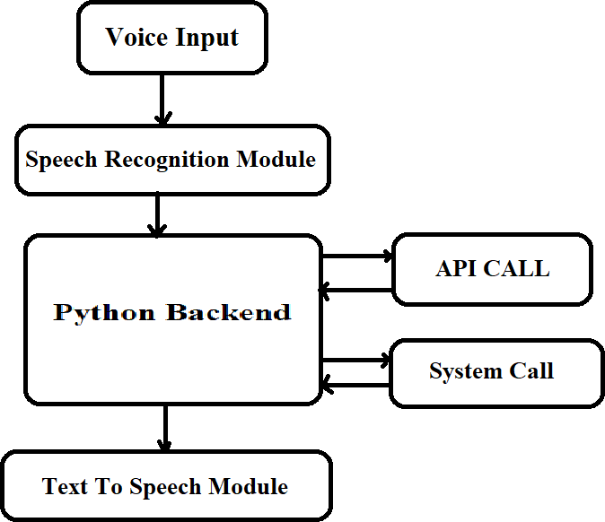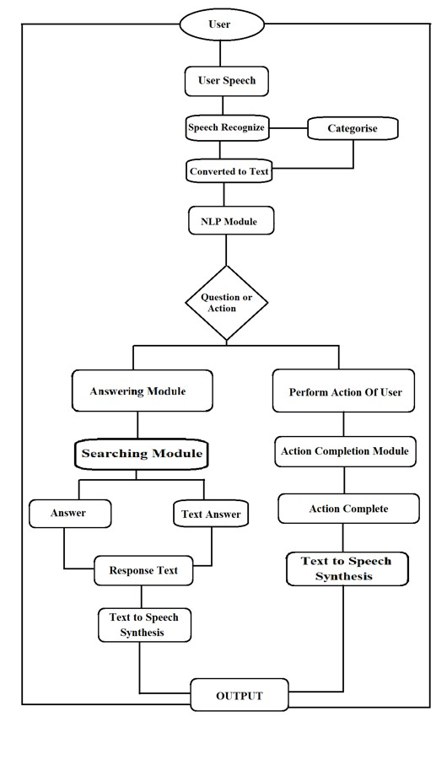

**CHAPTER 6: CONCLUSION**

A voice assistant, without any doubt, as it saves time for the user through conversational interactions, effectiveness, and efficiency. But while working on this project, there were some limitations encountered, and also realized some scope for enhancement in the future.

# REFERENCE

1. S. Subhash, P. N. Srivatsa, S. Siddesh, A. Ullas and B. Santhosh, "Artificial Intelligence-based Voice Assistant," *2020 Fourth World Conference on Smart Trends in Systems, Security and Sustainability (WorldS4)*, 2020, pp. 593-596, doi: 10.1109/WorldS450073.2020.9210344.
2. D. Pal, M. D. Babakerkhell and X. Zhang, "Exploring the Determinants of Users’ Continuance Usage Intention of Smart Voice Assistants," in *IEEE Access*, vol. 9, pp. 162259-162275, 2021, doi: 10.1109/ACCESS.2021.3132399.
3. E. Alepis and C. Patsakis, "Monkey Says, Monkey Does: Security and Privacy on Voice Assistants," in *IEEE Access*, vol. 5, pp. 17841-17851, 2017, doi: 10.1109/ACCESS.2017.2747626.
4. J. Leung, Z. Shen and C. Miao, "Goal-Oriented Modelling for Virtual Assistants," *2019 IEEE International Conference on Agents (ICA)*, 2019, pp. 73- 76, doi: 10.1109/AGENTS.2019.8929177.
5. E. H. -K. Wu, C. -H. Lin, Y. -Y. Ou, C. -Z. Liu, W. -K. Wang and C. -Y. Chao, "Advantages and Constraints of a Hybrid Model K-12 E-Learning Assistant Chatbot," in *IEEE Access*, vol. 8, pp. 77788-77801, 2020, doi: 10.1109/ACCESS.2020.2988252.
6. R. Zhang, X. Chen, S. Wen, X. Zheng and Y. Ding, "Using AI to Attack VA: A Stealthy Spyware Against Voice Assistances in Smart Phones," in *IEEE Access*, vol. 7, pp. 153542-153554, 2019, doi: 10.1109/ACCESS.2019.2945791.
7. H. Ali A., S. U. Rao, S. Ranganath, T. S. Ashwin and G. R. M. Reddy, "A Google Glass Based Real-Time Scene Analysis for the Visually Impaired," in *IEEE Access*, vol. 9, pp. 166351-166369, 2021, doi: 10.1109/ACCESS.2021.3135024.
8. C. Yan, G. Zhang, X. Ji, T. Zhang, T. Zhang and W. Xu, "The Feasibility of Injecting Inaudible Voice Commands to Voice Assistants," in *IEEE Transactions on Dependable and Secure Computing*, vol. 18, no. 3, pp. 1108-1124, 1 May-June 2021, doi: 10.1109/TDSC.2019.2906165.
9. P. Cheng and U. Roedig, "Personal Voice Assistant Security and Privacy—A Survey," in *Proceedings of the IEEE*, vol. 110, no. 4, pp. 476-507, April 2022, doi: 10.1109/JPROC.2022.3153167.
10. T. -K. Kim, "Short Research on Voice Control System Based on Artificial Intelligence Assistant," *2020 International Conference on Electronics, Information, and Communication (ICEIC)*, 2020, pp. 1-2, doi: 10.1109/ICEIC49074.2020.9051160.